**CS2050 Technical Documentation**

**Overview of Developer Technical Documentation**

**Set Up Development Environment**

Version Control with Git and GitHub

IDE Information

**General Resources**

Arrays

1D arrays

Rules for arrays

Encapsulation

# **Overview of Developer Technical Documentation**

My technical documentation includes:

* **Setup instructions**: Steps to configure my development environment (GitHub)
* **Version control**: Key commands for Git and how they work
* **IDE information**: Setting up and using IntelliJ IDEA, including downloading, installing JDK, and creating a new project.
* **General Resources**: Links to important resources
* **Modules**: Topics covered in modules

# **Set Up Development Environment**

1. Login to [GitHub](https://github.com)
2. Click on the “+’ icon and select “New repository.”

1. Enter a name and add .gitignore file then create the repository.
2. Go to IntellJ IDEA > File > Settings > Version Control > Git
3. Make sure that the path to Git is set correctly.

## Version Control with Git and GitHub

<https://docs.google.com/document/d/1lnLZdxusq1UNoUshdf3sK64QaTrNF5Iy/edit#heading=h.gjdgxs> contains information on how to set up Git and GitHub.

Git is a distributed version control system that tracks changes in code over time. It allows multiple people to work on the same project without messing up each other’s work.

GitHub is a developer platform that allows developers to create, store, manage, and share their code. It uses Git software to track changes and manage versions of code.

Important GitHub commands:

**git init** – Makes a repository (Only done once per repository)

**git status** – Extremely useful to check now and then

**git add** – Start tracking or include changes for a file

**git commit -m “message”** – Commit the changes with a message

**git push** – Push the branch to GitHub (remote)  
**git pull** – Pull the changes for the current branch

**git checkout -b** – Make a separate branch

**git reset - -hard** – Resets back to commit   
**git branch -D** – Deletes the branch

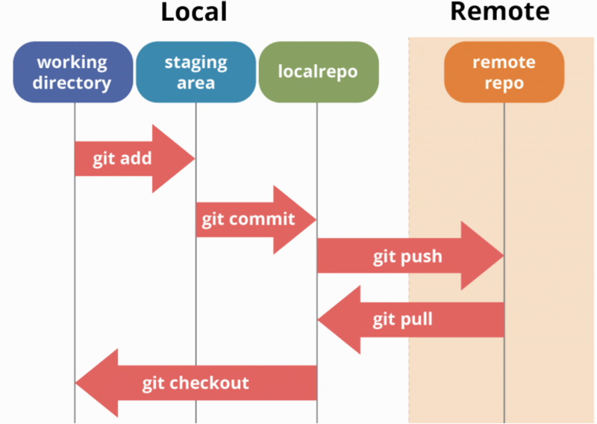

## IDE Information

Setting up a project with IDE

1. [Download JetBrains IntellJ IDEA](https://www.jetbrains.com/idea/download/?section=windows)  
   Choose windows  
   Complete Setup, and install required plugins
2. [Install JDK](https://www.oracle.com/java/technologies/downloads/)  
   JDK is required to compile and run Java applications
3. Create a New Project from the welcome screen  
   Click **File, New, and Project** if the welcome screen isn’t displayedA screenshot of a computer

   Description automatically generated
4. Right-click on your project and create a Java Class  
     
   A screenshot of a computer

   Description automatically generated
5. [More information (includes running, registering, updating, uninstalling, creating Java applications, features, plugins, etc.)](https://www.jetbrains.com/help/idea/run-for-the-first-time.html)

# **General Resources**

Here you can list resources that you use frequently.

* [Shared student resources containing resources, lectures and assignments](https://drive.google.com/drive/folders/1HvYY8zzSwlsH--03olvqOJooGnJkZ7F4)
* [Draft Schedule](https://docs.google.com/spreadsheets/d/1igBbmOBTXfvEVicyAggnqRIpV5Fwqh64/edit?gid=2047083326#gid=2047083326)
* [Link to join lecture in teams](https://teams.microsoft.com/l/meetup-join/19%3aklQhREluFbWiaroMMZPBYeNPhZa9AFGnTb7ATIPTUFE1%40thread.tacv2/1724008042961?context=%7b%22Tid%22%3a%2203309ca4-1733-4af9-a73c-f18cc841325c%22%2c%22Oid%22%3a%2233eb6fec-88d5-4bc1-bb67-32063f1cfacc%22%7d)
* [Syllabus](https://msudenver.instructure.com/courses/95281/assignments/syllabus)
* [Announcements](https://msudenver.instructure.com/courses/95281/announcements)
* [Modules](https://msudenver.instructure.com/courses/95281/modules)

## Arrays

An array is a data structure that provides a way to store more than one value. Arrays must be the same data type.   
  
There are several types of arrays:

## 1D arrays

- 1D array is used to store multiple values in a single variable  
- String[] cars;  
- To insert values, you have to place the values with commas inside curly braces  
- Int[] num = {1, 2, 3, 4, 5};  
- You can iterate these values with a loop (FOR, WHILE, DO WHILE) depending  
on what you need

This is how you declare and initialize a 1D array:

## Rules for arrays

1. When an array is created, its size is fixed. You can’t change the size of an array after it’s initialized.
2. The index for arrays starts at 0. The first element is at index 0, then 1..2..3.. etc.
3. You can get the length of an array using the .length attribute.
4. Everything inside the array needs to be the same type. For example, you can’t mix strings and integers. It can’t hold elements of mixed types.
5. If an array is created but not initialized, it will default to the value 0 for integers and null for reference types.
6. ArrayIndexOutOfBoundsException happens when the index is outside the bounds of an array (Remember the array starts at index 0).

## Encapsulation

Encapsulation is to make sure that “sensitive” data is hidden from users.

How to:

Declare class variables/attributes as private.

Provide getter and setter methods to access and update the value of a private variable.

Getter and setter methods:

More information: <https://www.w3schools.com/java/java_encapsulation.asp>